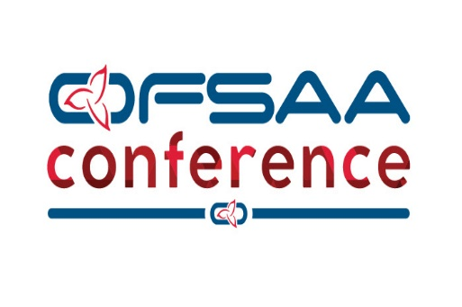

Call for Presenters!

We are looking to fill our slate of presenters for the 2019 OFSAA Conference. This conference is a professional development opportunity for physical education teachers, teacher-coaches, athletic directors and school administrators and will be held May 9th and 10th at Durham College in Oshawa.

An honorarium of $175.00 will be given for each session, as well as accommodation (if needed) and meals surrounding your session.

Please fill out the presenter application form attached below form. Please submit the form by no later than Thursday, February 28th, 2019 in order to be considered for a presenter spot.

We are always looking for new session ideas! If you have any questions please email Denise Perrier denise@ofsaa.on.ca, or by phone at 416-426-7436.

CALL FOR PRESENTERS
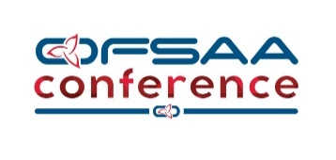
Durham College, Oshawa, Ontario
May 9 & 10, 2019
OFSAA is looking for energetic educators to present at the 2019 OFSAA Conference. Focus of the conference will be professional development opportunity for physical education teachers, teacher-coaches, athletic directors and school administrators. CIAAA courses will be offered for athletic directors as well as the CIOS course
An honorarium of $175.00 will be given for each session, as well as accommodation (if needed) and meals surrounding your session.
The conference provides sport specific skills, drills and strategies through on-court and classroom sessions. The program has introductory and advanced sessions that will benefit both new and seasoned coaches. Best practice sessions will also be offered for new and experienced educators; providing strategies and information useful to any physical education environment.
*Please see the OFSAA website at www.ofsaa.on.ca – Conferences & Events – OFSAA Conference – For Schedule Updates
All presenters will receive an honorarium, registration discount or REGISTRATION FREE OF CHARGE!!
Name:
School/Sport Affiliation:
Address:
Phone:
FAX:
Email:
Coaching certification /past experience:
Level of presentation:
Synopsis of session (attach additional pages & information if necessary):
Presenters must provide a curricular based resource. The resource will be distributed to delegates.
Please complete form and return no later than February 28, 2019 to:
Denise Perrier – OFSAA Ph: 416-426-7436
Email: denise@ofsaa.on.ca

